Product: | Stellarium
Date:
Author:

Purpose:
- Introduce main controls
- Show ways to navigate and find information

# | Action on Screen | Audio
 |  | Hello. In this video I’m going to show you the basics of using Stellarium, which is a free planetarium program for your computer.
 | 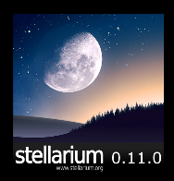 | After you download and install Stellarium, open it up. By default it’ll be in full-screen mode.
 |  | To look around in Stellarium, left click and drag anywhere.
 |  | While the view is nice during the day, it’s most interesting at night.
 | 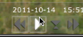 | To change what time stellarium shows, go down to the menu at the bottom, to the time control buttons.
 |  | Click the speed up button several times to make things move a bit quicker.
 |  | When you get to the time at night you want, click the play button to return to the normal rate.
 |  | If you take a minute to scroll around, you’ll just see a bunch of stars, with perhaps a few labels.
 |  | To show more, in the menu at the bottom you can turn on labels for…
 | 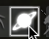 | …planets…
 | 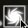 | …nebulas…
 | 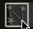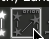 | …as well as constellation lines and names.
 | 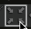 | To get a zoomed in telescopic view of an object, click on it, center it by clicking this button (or press the spacebar)…
 | 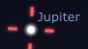 | …then either scrolling or pressing the page up key on your keyboard multiple times.
 | 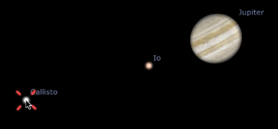 | As you can see with Jupiter, once you’re zoomed in, you can also select and get information on its moons.
 |  | Some of this information that may the most interesting is the magnitude, which refers to its brightness,
 |  | The “RA/DE” and “Az/Alt” coordinates, which are two different ways of plotting objects in the sky,
 |  | And obliquity, which compares the axis of its rotation to its orbit.
 | [show URL in callout]  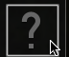 | If you have other questions about how to use Stellarium, you can always check out the application’s in-product help via this button or go to the website at www.stelarium.org.
 |  | Thanks for watching.

